
(Applications of a Triangle’s Centers)

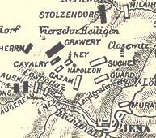
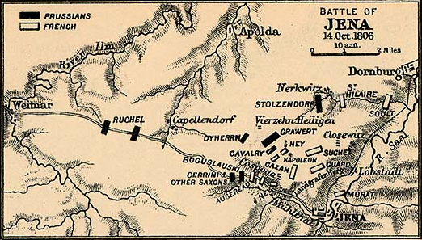
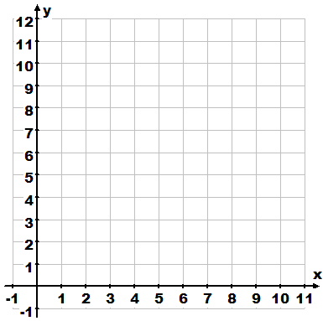
Napoleon Bonaparte once stated “The advancement and perfection of mathematics are ultimately connected with the prosperity of the state.”
Consider this map of the Battle of Jena below:

The triangle outlines almost all of Napoleon’s Troop Encampments. Napoleon was always attempting to apply mathematics to his military strategies. If Napoleon had wanted to strategically place a central camp so that he had the easiest access to all of his troop encampments, where should that center be and why? Open up Geometer’s Sketchpad, and plot the three points that define the triangle above and scale the axis to make the triangle larger. If Napoleon had wanted to strategically place a central camp so that he had the easiest access to all of his troop encampments, where should that center be and why?

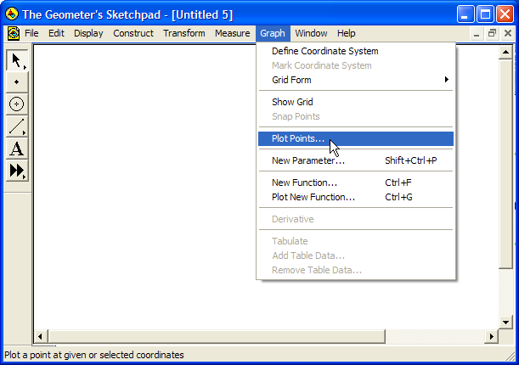
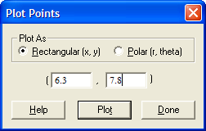
- Select Plot Points… from under the Graph Menu. Type in the vertices of the first vertex from above and press the button. Continue typing in each vertex and pushing the button after each. After all three vertices have been plotted, press .

M. Winking p.6
e-mail: wiseone@mindspring.com

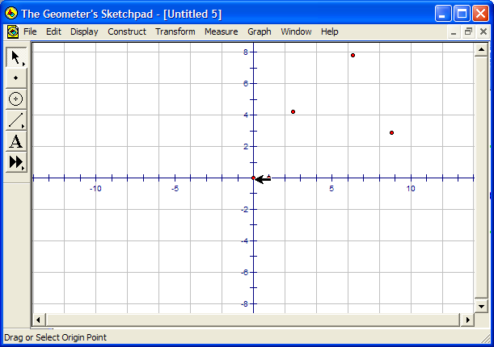
Next, click and drag the origin point down toward the bottom left hand corner of the screen (this is to make the triangle plot larger to work with).
Move this origin point down to the bottom left hand corner of the sketch

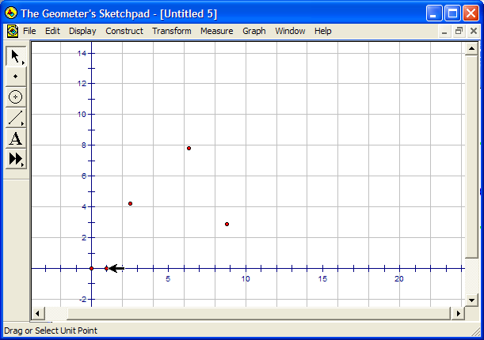
- Now, drag the unit point at (1,0) to the right to increase the unit size of the graph until the vertices of the triangle are spread a little more.
Move this unit point to the right to increase the unit length of the graph.

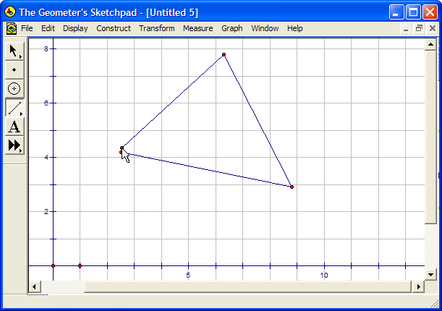
- Using the line tool, , connect each of the vertices to create the triangle as shown at the right.

- Construct each of the common center’s of the triangle (Centroid, Incenter, Circumcenter, Orthocenter). Although they are all relatively close, If Napoleon had to pick one of the center’s to place a central camp that had the best access to all of his troops which center do you think would mathematically be the best

and why?

M. Winking p.7
e-mail: wiseone@mindspring.com
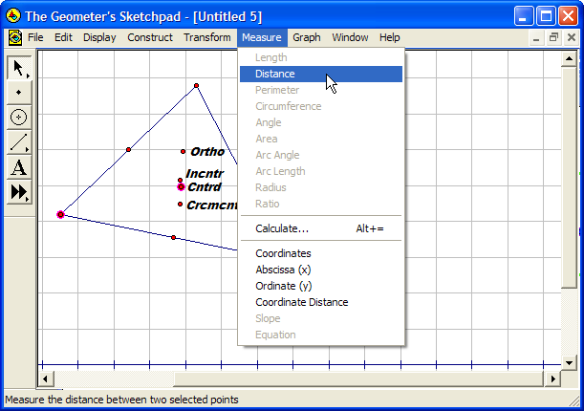
- Let’s analyze each. First measure the distance from the centroid to the top vertex. Then, the distance from the centroid to the right vertex and finally, the distance from the centroid to the left vertex. To measure the distance, simply click in a blank space to deselect everything first. Then, select and highlight the two points that you want to measure the distance between at the same time and select Distance under the Measure menu. (shown at the right)

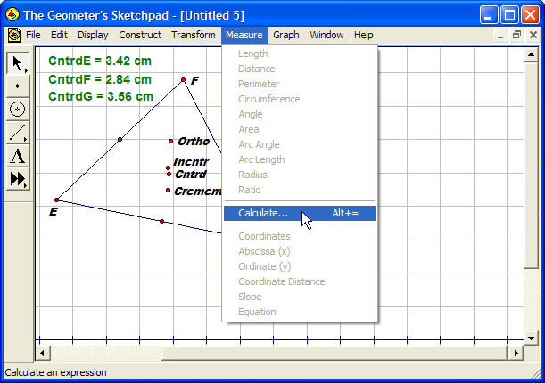
- After all three measures have appeared, select Calculate… under the Measure menu.

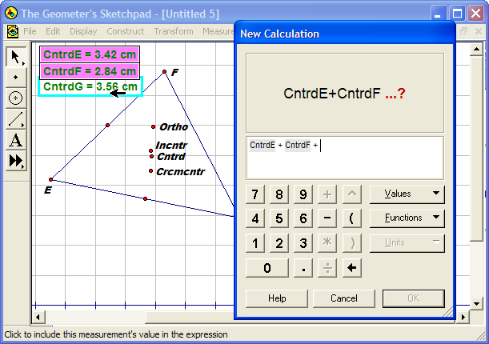
- A calculator type window should appear. To total the distances, start by literally click on the measure on the top measure in the sketch. Then, click the on the calculator. Next, click on the second measure and click the on the calculator. Finally, click on the last measure and .
IMPORTANT!: Just click on these measures in the sketch to get them to appear in the calculator.

- This should total the distance from the centroid to each of the vertices. Do the same calculation for each center. Which of the four center’s has the minimum distance?

M. Winking p.8
e-mail: wiseone@mindspring.com
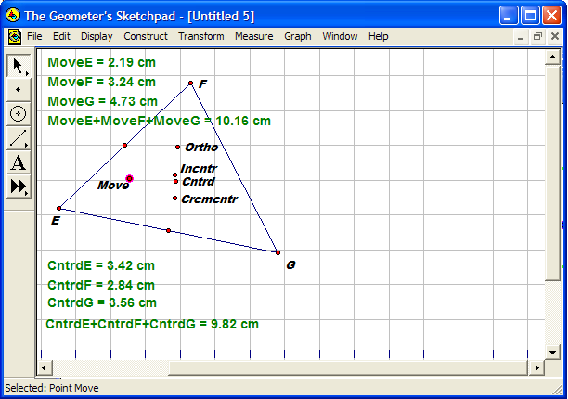
- Do you think you can do better by just placing a point in the center of the triangle somewhere? To try it, using the point tool, , just create a random point somewhere inside the triangle.

- Using the Label tool, , label the new point “Move”.

- Next as we did earlier, measure the distance from the point “Move” we just created to each of the vertices and total the distance.

- Try moving the point around and see if you can find a better center to minimize the distance to the vertices.

- What are the approximate coordinates of the point that minimizes the distance between the three vertices?

- If you keep the movable point inside the triangle what are the coordinates of the absolute worst place you could put the camp (such that it creates the maximum distance between the three vertices)?

- Is looking at minimizing the distance between the three vertices the best way to find the ideal center? Explain why you think either this is the best way or what a better way might be.
.

Laplace and Fermat actually studied this same problem in the 1800’s and Fermat came up with a point he was able to call “Fermat’s point”. He found a new center of a triangle. Recently, using Geometer’s sketchpad some high school students actually found a new triangle center that had never been discovered. Maybe you can find one and name it your point.

M. Winking p.9
e-mail: wiseone@mindspring.com

Cell Phone Tower
A cell service operator plans to build an additional tower so that more of the southern part of Georgia has stronger service. People have complained that they are losing service, so the operator wants to remedy the situation before they lose customers. The service provider looked at the map of Georgia below and decided that the three cities: Albany, Valdosta, and Waycross were good candidates for the tower. However, some of the planners argued that the cell tower would provide a more powerful signal with the entire area if it were placed somewhere between those three cities. Help the service operator decide on the best location for the cell tower.
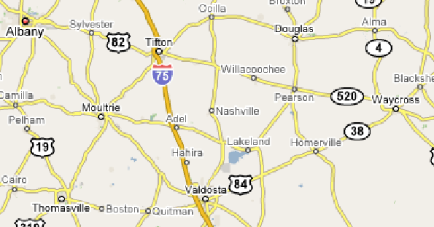
- Just looking a the map, choose the location that you think will be the best for building the tower. Explain your reasoning.
.
- Now you are going to use some mathematical concepts to help you choose a location for a tower.
Try using Geometer’s Sketchpad to create a short report where you think the cell phone tower should go. You must investigate the four common center’s (centroid, orthocenter, circumcenter, and incenter) as possible placements.

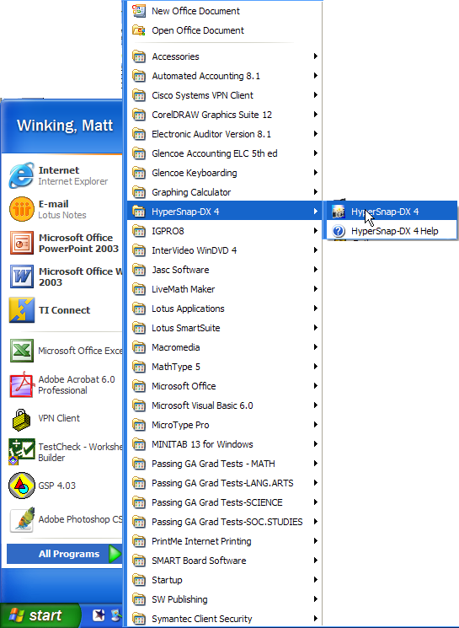
- Use Google Maps to find a map of south Georgia and then Hyper Snap to capture a part of the map as a picture and then paste picture of the map into to Geometer’s Sketchpad. Once your picture is in Geometer’s Sketchpad, right click on the map in sketchpad and select Properties…. Uncheck the box next to “Arrow Selectable” and click OK. Now, start CONSTRUCTING your REPORT!!!!!!
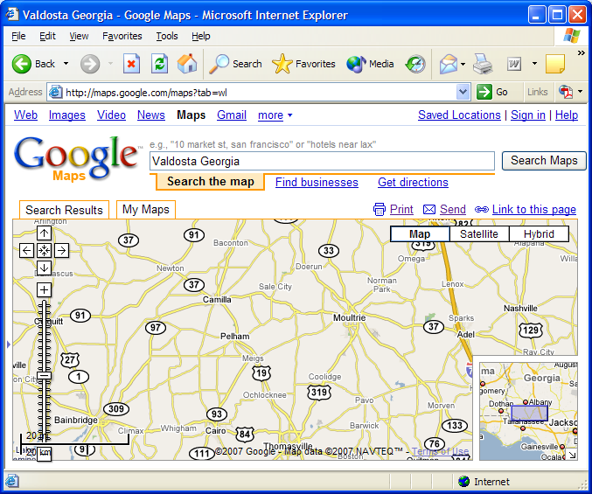

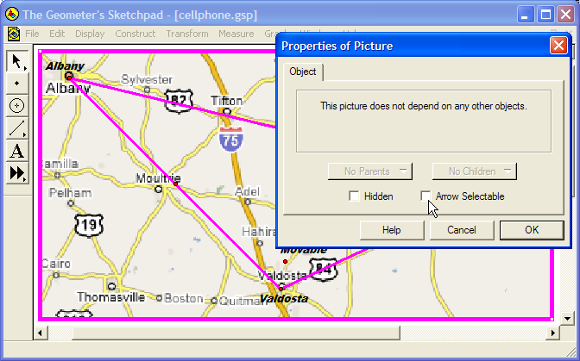
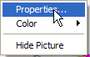

M. Winking p.10
e-mail: wiseone@mindspring.com

